## Social Media Aggregator (Name TBD)

Project Design Proposal

Ian Donovan, Jake Hall

### Project Overview

Social Media Aggregator (shortened to SMA) is planned to be a website which allows users to simply access all their news feeds and profiles for every common social media platform in today’s day and age. Rather than polluting screen space in your browser, SMA intends to consolidate it all into one place. After signing in using first-party OAuth buttons, a user could check their notifications and relevant posts across all platforms, as well as make posts to them.

### Market & Impact

Social media management tools aren’t a novel idea. There are already tools that perform this function such as HootSuite, but all of them are intended for commercial usage; they’re built with features specifically tailored for marketing agencies and cost hundreds of dollars for licensing. Some of the tools out there are even horribly outdated in terms of presentation/ease of use. Thus, most people either cannot afford these tools or run the risk of them being suboptimal.

SMA by contrast is meant to be accessible for the common person, targeting the core usage and then working outwards from there based on time constraints. If we have bandwidth, we also hope to implement features like creating posts that can be simultaneously uploaded to multiple social medias, the ability to access inbox messages on every platform, and the ability to tap into currently trending topics/hashtags. Given that we live in an online world of freelance musicians, artists, streamers, and content creators, these features would be infinitely helpful to them as they could maintain a social presence and update easier.

### List of Components (Software, Hardware, Network)

Software Components:

* Programming Languages*
  + HTML
  + CSS
  + JavaScript
* Frameworks/Libraries*
  + jQuery
  + React
* APIs
  + Facebook’s Software Development Kit (SDK)
  + Twitter’s Developer API
* IDEs of the Developer's Choice
  + Atom
  + Sublime Text 3
* Web Browsers for Testing
  + Google Chrome
  + Mozilla Firefox
  + Microsoft Edge

Hardware Components:

* Development Machines
  + Laptops
  + Desktops

Network Components:

* Website Hosting
* Domain Name

*\*Additional languages/frameworks may be added to improve development time (e.g.: API wrapper libraries) or to provide secure, server-side scripting (e.g.: Node.js, PHP) for our API interactions.*

### What Has Been Done

Thus far in the project we have setup all git repositories, implemented a simple website structure with basic styling, some jQuery to add content dynamically, as well as basic login using Facebook’s SDK. We are also hosting it for now off GitHub Pages, so that we can view our code live.

Aside from that, we’ve been researching both the Facebook and Twitter documentation, and planning on how to implement this page best. As we develop we intend to take full use of each social media’s own web components. This way we can easily ensure clean, embedded posts that are familiar a user and easy to maintain.

### Design Decisions Made So Far

Due to the nature of the project many of the specific design choices cannot be made until more of the project’s framework has been developed in code. Currently we do have some important decisions made. These include the choice to focus on the implementation of Facebook and Twitter into the social media aggregator first and then add other platforms in should time allow upon project completion. This will force us to both not overextend ourselves on the initial build of SMA, and create modular code that can be implemented for multiple social media platforms. In addition, we have decided that signup and login will be done using implemented social media platforms, removing the need to develop and authentication program and a database to store user information such as passwords. We have also decided on the basic layout of the website (see pictures below). The main page will contain a sidebar with icons of social media platforms. These can be selected to display your that ‘timeline’. The currently selected social media page will be split up into sections such as your ‘Timeline’, creating a post, and viewing recent activities.

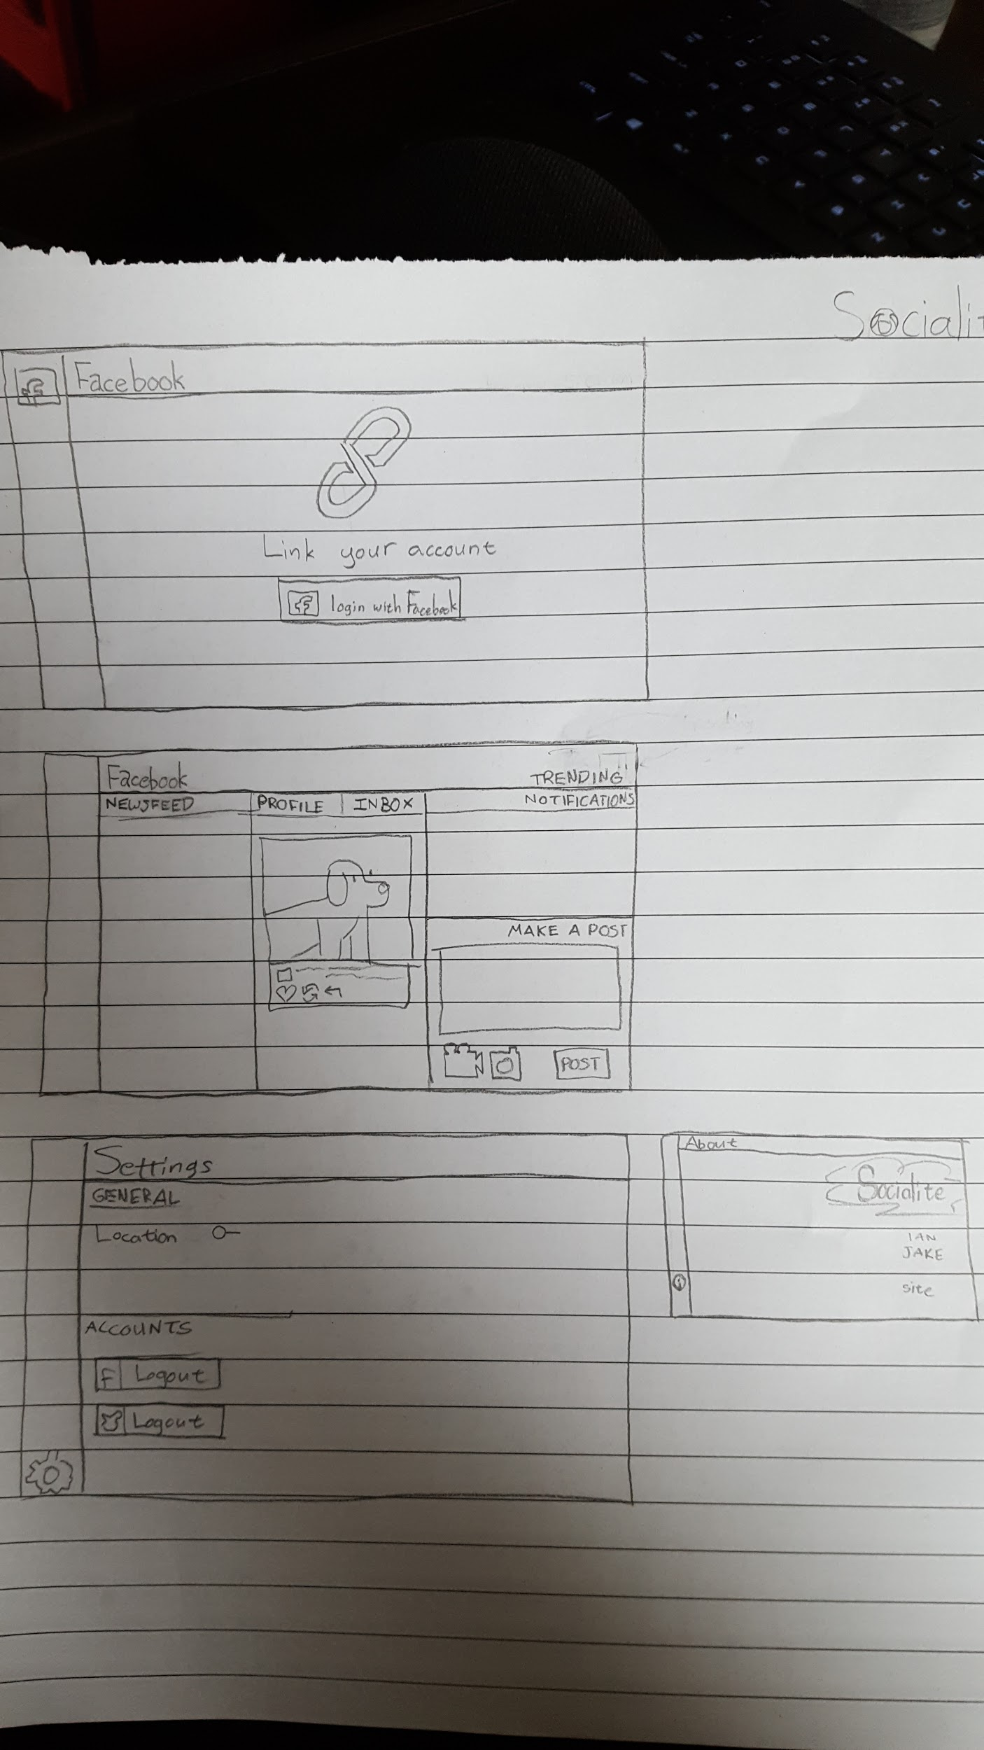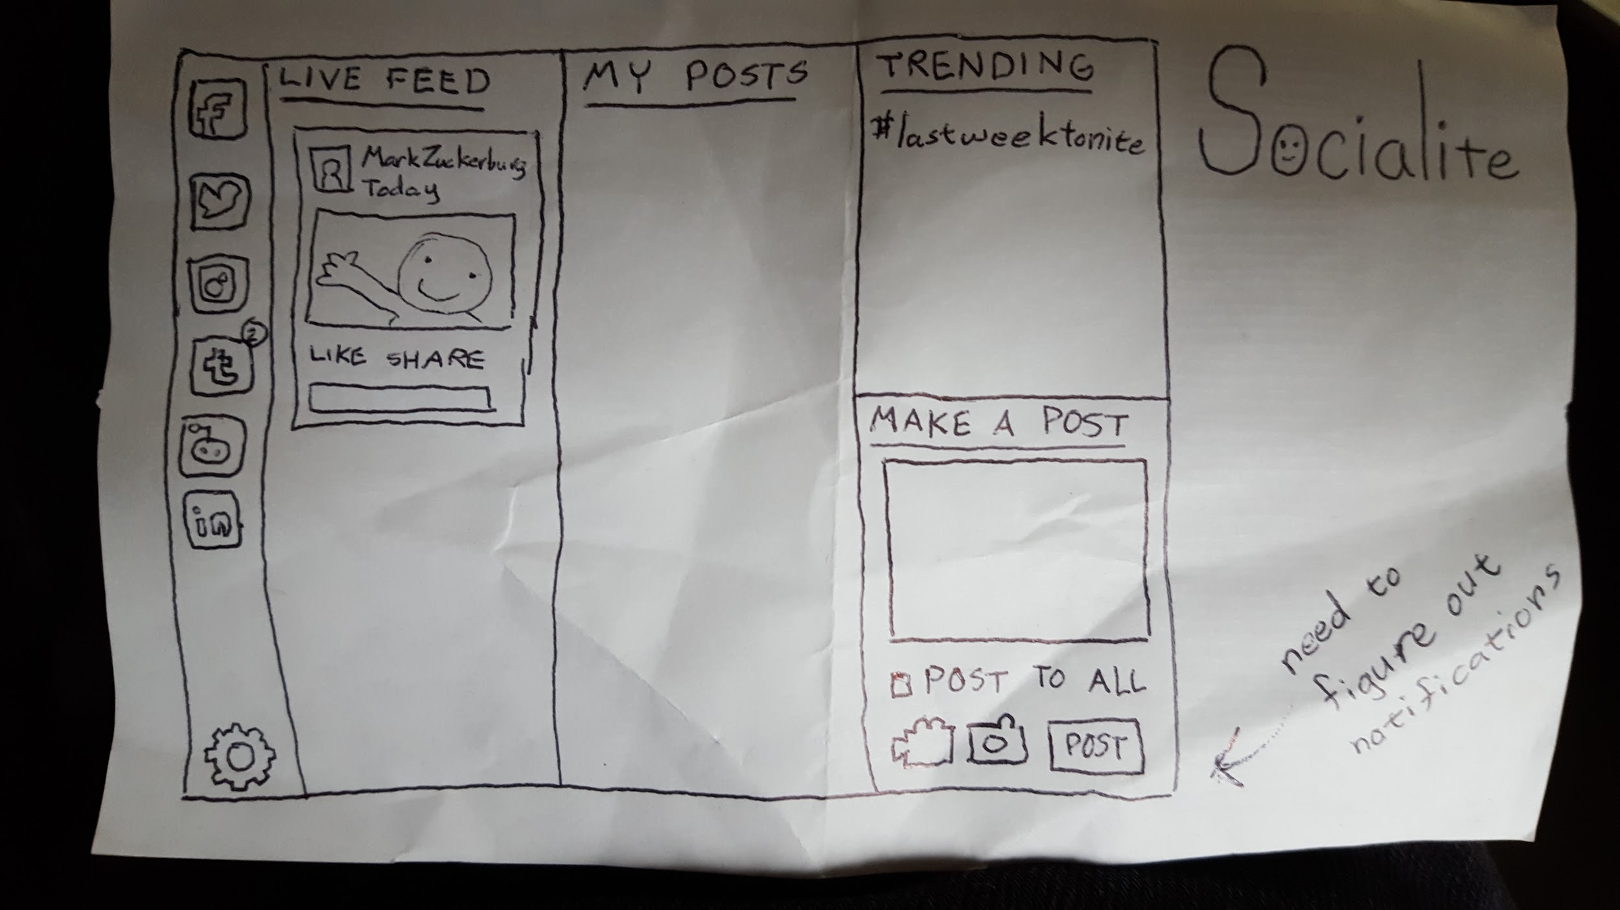

### Design Decisions Yet to Be Made

* Preferred server-side scripting languages would be necessary if the decision is made to use them.
* Best approaches to structuring the pages/source.

### Milestones on Our Timeline

The milestones we created for SMA are broken down weekly to keep us steadily completing the project.

Weeks 1 and 2: Come up with a project idea.

Week 3: Complete research into Facebook and Twitter APIs.

Week 4 (This week): Implement a rough webpage with the ability to login using Facebook or Twitter.

Weeks 5 and 6: Complete the front-end development by creating the website shell that the backend will fill with correct values.

Weeks 7 and 8: Complete the backend development by implementing the APIs to interact and fill in details created during weeks 5 and 6.

Week 9: Create the settings page. This will contain code to unlink social media platforms, as well as other various settings that have yet to be determined.

Week 10: Implement a “Share to all” function that will make a post across all linked social media platforms (or the ones the user selects).

Week 11: Finalize the Minimal Viable Product (V 1.0.0). This includes cleaning up code, placing additional comments, removing unused files, etc.

Weeks 12 +: Prepare for presentations along with implementing additional goals should time allow.

### Project Goals for This to be Considered a Success

The criteria for this project to be considered a success are very straightforward. SMA will be considered a success when it is a working website that allows users to sign in to, access, and user at least two social media platforms through our single site. SMA will have the ability to switch between the linked social media site, as well as make a post between the connected sites. The user will also be able to disconnect/reconnect their profile from the sites as needed.

### Additional Goals

Following us successfully completing our minimal viable product requirements (v 1.0.0), we have the following extra features we can accomplish:

1. Controlling private message inboxes, so that users can chat with their friends without leaving the platform, helping centralize many of the communication platforms present.
2. Cross-platform posting - creating posts that can be sent to all possible platforms simultaneously.
3. Collecting information on trending topics on various social media sites if provided via the API and presenting it within each site’s view.

### Unknowns or Concerns That Could Lead to Failure

Going into this project there are unknowns that could spell issues for SMA. The foremost one is the concern that the APIs will not provide the level of flexibility that is needed to implement this website. The second concern is that the APIs will cap our request to the extent that the site is being updated infrequently. Finally, neither Ian nor Jake, has experience with web development, as such our inexperience could cause us to make mistakes and not follow best practices leading to issues with the code down the line.